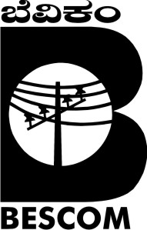
BANGALORE ELECTRICITY SUPPLY COMPANY LIMITED

MODEL SUB DIVISION & SYSTEM IMPROVEMENT WORKS:

Scope of work:
- 11kV New link lines/New feeders
- Conversion of overhead by UG cables - 11 KV Feeders
- Conversion of LT overhead by LT UG cables/ AB Cable
- Conversion of overhead Service Mains by UG service mains.
- LT AB Cable in Hazardous Location
- Refurbishment of Existing DTC/ Providing 5 star rated Distribution Transformers.
- Providing Additional Transformers and compact substations.
- Providing DAS compatible RMUs

Advantages:
- Reducing the interruptions and to improve reliability index.
- Improving quality of power supply and to increase safety environment by using underground cable system exclusively in urban areas
- To reduce the length of trunk line thereby reducing the technical losses
- To reduce AT&C losses, Reduction in accidents.

Model sub division works are implemented in S10, S13, E8 and N4 and system improvement works in E3 sub division in BMAZ area of BESCOM. All the works in E8 and N4 subdivision is completed and in S10 (S19), S13 and E3 works are completed restricting to the Detailed Work Award amount. The total awarded amount for all the 5 sub divisions is Rs.951.51 Crores and the expenditure booked is Rs.928.57 crores.

